**933052808**

Agreement url:   
http://lxsj.cstam.org.cn/CN/1000-0879/home.shtml

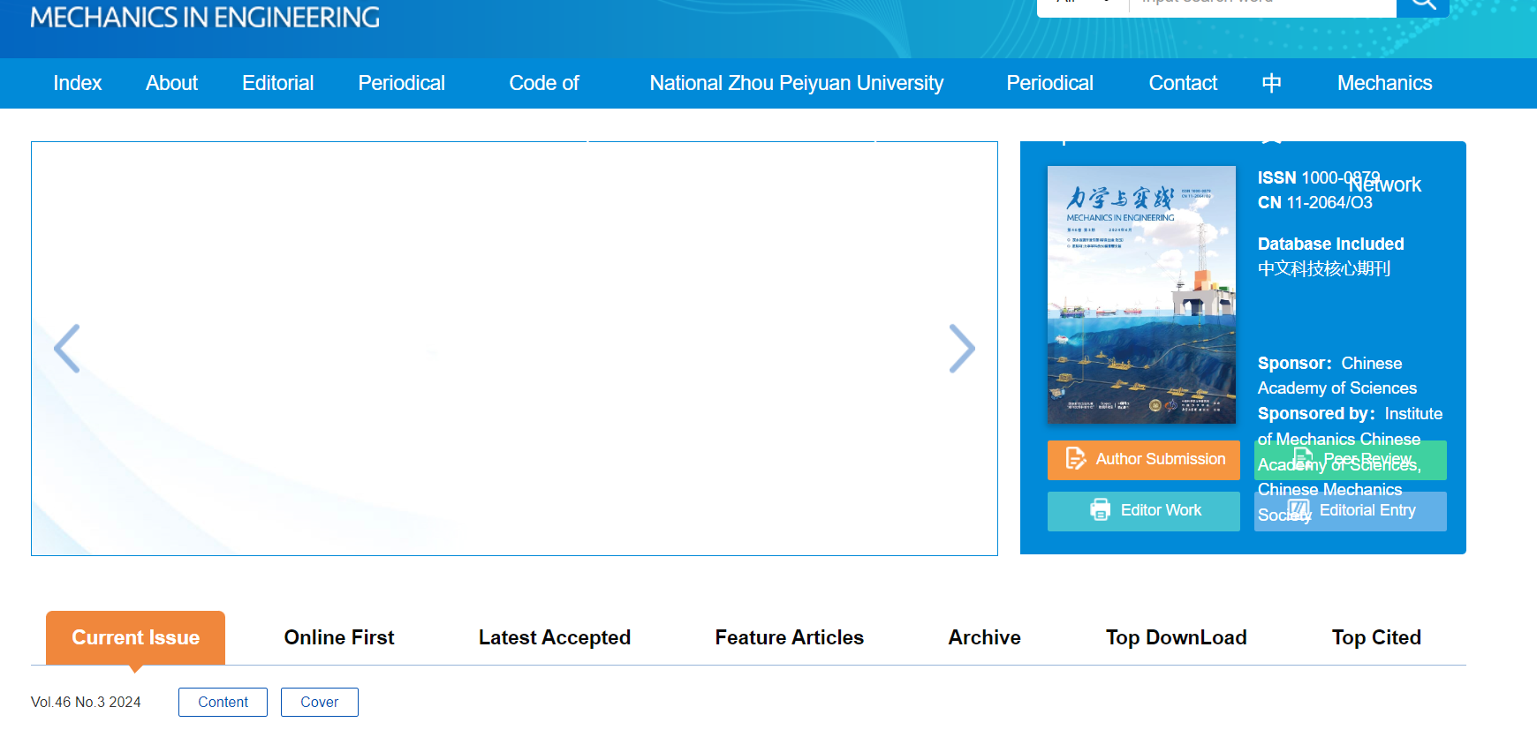

Current issue

Select English Version

Publication year, volume, issue

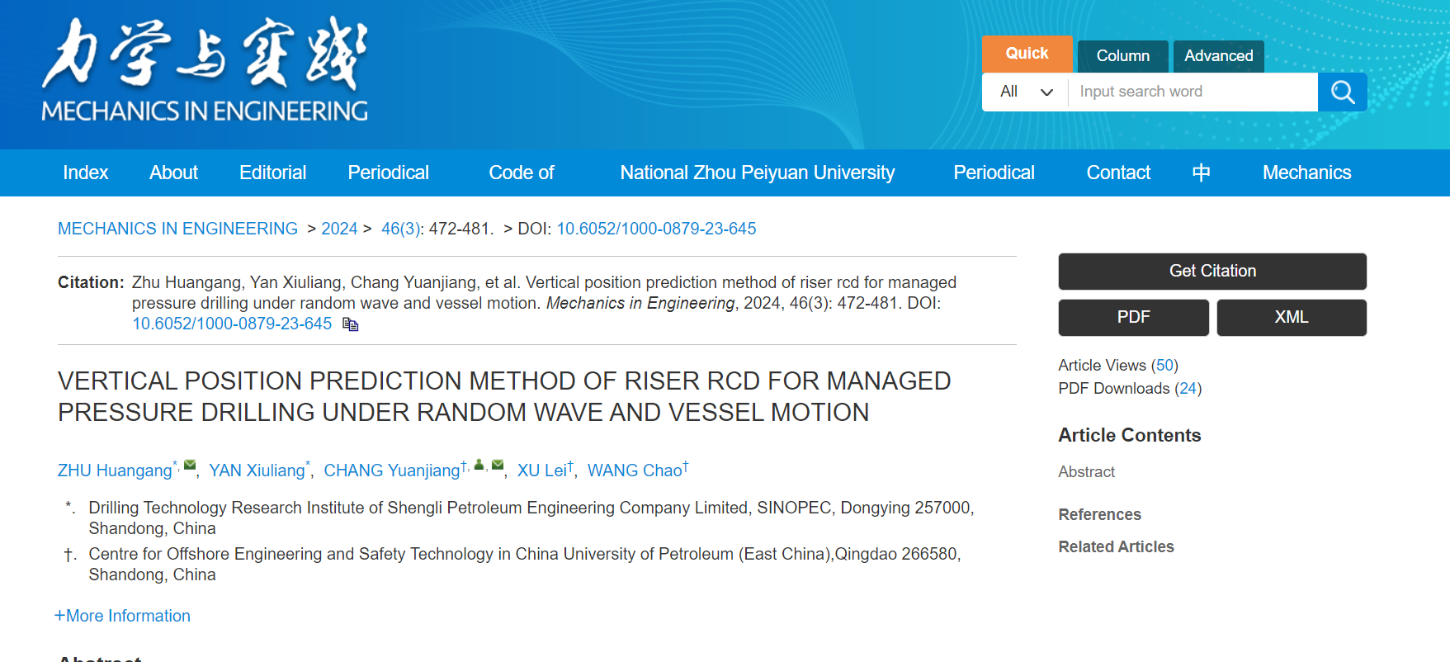

Download the pdf

DOI

Page range

English title

* **In here both English and Chinese toc needs to be captured so choose language option from website language conversion . then go to the Table of content page right click and save as pdf and merge in to one.**